Arabic Text Summarization with T5 Model Documentation

**Introduction:**

This script implements Arabic text summarization using a pre-trained transformer model called T5 (Text-to-Text Transfer Transformer). T5 is a state-of-the-art transformer model developed by Google Research, known for its versatility in handling various natural language processing tasks. Specifically, this implementation focuses on leveraging the T5 model for summarizing Arabic texts, condensing lengthy passages into concise summaries while retaining the essential information.

**pretrained Transformer Model: T5**

The T5 model, short for Text-to-Text Transfer Transformer, is a transformer-based architecture introduced by Google AI. It represents a significant advancement in the field of natural language processing (NLP), offering a unified framework for a wide range of NLP tasks. Key characteristics of the T5 model include:

Text-to-Text Framework:

Unlike traditional models that specialize in specific tasks (e.g., classification, translation), T5 is trained in a text-to-text manner. This means it learns to map input text to output text for a variety of tasks, including summarization, translation, question answering, and more. This unified approach simplifies training and allows for easier transfer to new tasks.

Versatility**:**

T5 exhibits remarkable versatility, capable of performing multiple NLP tasks with minimal task-specific modifications. By framing all tasks as text generation tasks, T5 demonstrates strong performance across diverse domains and languages.

Multilingual Capabilities:

T5 is trained on multilingual data, enabling it to understand and generate text in multiple languages, including Arabic. This makes it particularly suitable for tasks involving Arabic text processing, such as summarization, translation, and sentiment analysis.

Large-scale Pre-training:

T5 is pre-trained on vast amounts of text data using self-supervised learning techniques. This pre-training process enables the model to capture rich linguistic patterns and semantic relationships, leading to robust performance on downstream tasks.

**Data used for Fine-Tuning:**

For fine-tuning the T5 model for Arabic text summarization, a dataset consisting of 29,201 samples was used. The dataset contains two columns:

summary: The target summaries, which are concise representations of the corresponding input texts.

text: The input Arabic texts that need to be summarized.

**Code Structure:**

Data Loading and Preprocessing:

The dataset, containing Arabic texts, is loaded from a CSV file using pandas, a powerful data manipulation library.

preprocessing involves filtering the dataset to include Arabic texts shorter than a specified length to facilitate faster training.

The dataset is then split into training and validation sets using sklearn's train_test_split function.

**Dataset Preparation:**

A custom dataset class (SummaryDataset) is defined to handle the tokenization of input Arabic texts and summaries.

The T5 tokenizer, trained on Arabic text, is utilized to tokenize both the input texts and the summaries.

**Data Module:**

A PyTorch Lightning LightningDataModule (SummaryDataModule) is implemented to organize the training and validation datasets efficiently.

Data loaders for training and validation sets are set up within this module.

**Model Definition:**

The T5 model class (T5SumModel) is defined as a PyTorch Lightning module.

Methods for the forward pass, optimizer setup, training, and validation steps are implemented within this class.

**Training Setup:**

Training parameters such as learning rate, batch size, and maximum epochs are configured.

The model is initialized, and the trainer is set up with appropriate parameters.

**Results:**

Average ROUGE-1 F1 Score: 0.027266899766899767

Average ROUGE-2 F1 Score: 0.004318181818181817

Average ROUGE-L F1 Score: 0.027266899766899767

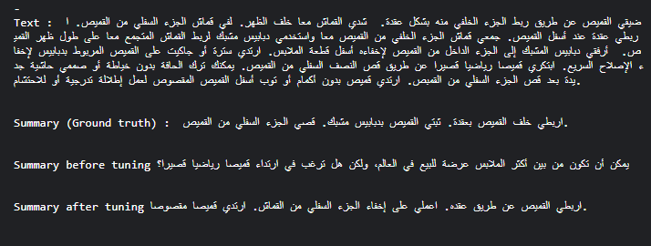

**Comparison between mT5_multilingual_XLSum model and bart-large-cnn model :**

**mT5_multilingual_XLSum:**

Model Type: This model is based on T5 (Text-To-Text Transfer Transformer), which is a variant of the Transformer architecture. It's specifically tailored for multilingual summarization tasks.

Multilingual: As the name suggests, it's designed to work with multiple languages, which means it can understand and generate summaries in various languages.

XLSum: The model is trained using the XLSum dataset, which is a large-scale dataset for extreme summarization tasks.

Fine-Tuning: The model can be fine-tuned for specific summarization tasks in different languages or domains.

facebook/bart-large-cnn:

Model Type: BART (Bidirectional and Auto-Regressive Transformers) is a variant of the Transformer architecture developed by Facebook AI. It combines auto-regressive and masked language modeling objectives.

Large Model: "Large" in the name indicates that this model has a large number of parameters, which often leads to better performance but requires more computational resources.

CNN: This variant of BART has been trained on CNN/DailyMail dataset, which consists of news articles paired with human-generated summaries.

Pre-training: BART has been pre-trained on a large corpus of text data, which helps it understand language patterns and generate coherent summaries.

**Comparison:**

Multilingual Capability:

While mT5_multilingual_XLSum is explicitly designed for multilingual summarization, BART models are primarily trained on English but can be fine-tuned for other languages.

Task Specificity:

mT5_multilingual_XLSum is specifically tailored for summarization tasks, whereas BART models are more versatile and can be used for a range of tasks beyond summarization, such as text generation, translation, and more.

Training Data:

training data for both models differ. mT5_multilingual_XLSum is trained on the XLSum dataset, whereas BART-large-CNN is trained on the CNN/DailyMail dataset.

Model Size:

BART-large-CNN is a larger model compared to mT5_multilingual_XLSum, which might lead to better performance but also requires more computational resources.

**Results after fine tuning:**

MT5:

Average ROUGE-1 F1 Score: 0.027266899766899767

Average ROUGE-2 F1 Score: 0.004318181818181817

Average ROUGE-L F1 Score: 0.027266899766899767

Bart:

Average ROUGE-1 F1 Score: 0.015507736943907155

Average ROUGE-2 F1 Score: 0.002173913043478261

Average ROUGE-L F1 Score: 0.015507736943907155

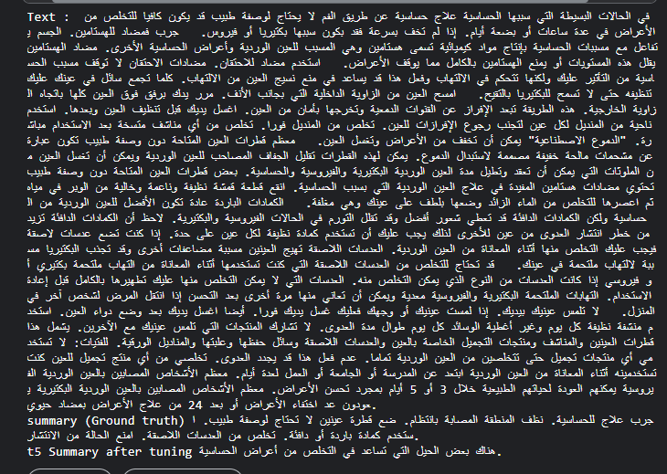

In summary:

mT5_multilingual_XLSum is specialized for multilingual summarization tasks, while BART-large-CNN is a more general-purpose model that can be fine-tuned for summarization among other tasks. The choice between them would depend on specific requirements such as language support, task complexity, and available computational resources.

**References**

T5 Paper: Exploring the Limits of Transfer Learning with a Unified Text-to-Text Transformer: The original research paper introducing the T5 model and its text-to-text framework.

Hugging Face Transformers Documentation: Documentation for the transformers library, which provides access to pre-trained T5 models, including those trained on Arabic text.

PyTorch Lightning Documentation: Documentation for PyTorch Lightning, a library that simplifies PyTorch code and provides additional functionality for training neural networks efficiently.